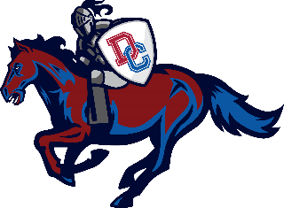Dundee-Crown Booster Club
AGENDA
_____________________________________

October 11, 2021 | 7:00 PM
- Call to Order

- Recognition of guests

- Approval of September 2021 Meeting Minutes

4. Athletic Director Report Steve

5. Committee Chair Reports
a. Concessions Manager Eydie
b. Volunteer Coordinator/Parent Representative Manoli
c. Website/Communications Melissa
d. Spirit Wear Holly

6. Treasurer Report Jeanette
a. Financial Statements
b. Update on a special account for athletes in need

7. Vice President Report TBD
a. Charger Chow Update (provided by Jennifer Miller)

8. President Report Dan
a. Confirm Dinner Dance Date
b. Spring Golf Outing Update

9. Old Business

10. New Business

11. Upcoming Events:

12. Adjournment

Next Meeting – November 8, 2021 @ 7:00 pm

